**Report on BodyPerformance Dataset Analysis**

**Introduction:**

This report provides a comprehensive analysis of the BodyPerformance.csv dataset. The analysis includes descriptive statistics, data visualization, and inferential statistics to understand the underlying patterns and make informed conclusions about the population from which the sample is drawn.

* Descriptive Statistics

Descriptive statistics provide a summary of the central tendency and variability of the dataset.

* Central Tendency

Mean and median values were calculated for continuous variables such as age, height, weight, body fat percentage, etc.

**Central Tendency (Mean):**

age 36.775106

height_cm 168.559807

weight_kg 67.447316

body fat_% 23.240165

diastolic 78.796842

systolic 130.234817

gripForce 36.963877

sit and bend forward_cm 15.209268

sit-ups counts 39.771224

broad jump_cm 190.129627

* Measure of Variance/Standard Deviation

Variance and standard deviation were computed to understand the spread of the data around the mean.

**Variance:**

age 185.658051

height_cm 71.007293

weight_kg 142.794526

body fat_% 52.661786

diastolic 115.391275

systolic 216.500428

gripForce 112.887736

sit and bend forward_cm 71.515386

sit-ups counts 203.824115

broad jump_cm 1589.457435

**Standard Deviation:**

age 13.625639

height_cm 8.426583

weight_kg 11.949666

body fat_% 7.256844

diastolic 10.742033

systolic 14.713954

gripForce 10.624864

sit and bend forward_cm 8.456677

sit-ups counts 14.276698

broad jump_cm 39.868000

**Data Visualization:**

Various plots were used to visualize the data:

* Histograms were generated for continuous variables to observe the distribution of data.

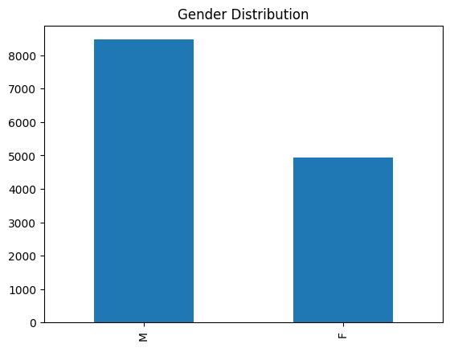

* Bar plots showed the frequency of categorical variables like gender and class.



**Inferential Statistics:**

Inferential statistics were performed to make predictions or inferences about a larger population using data drawn from a subset of that population.

* Confidence Interval
* A 95% confidence interval for the mean weight was calculated, providing an estimate of the range in which the true mean weight of the population lies.
* Hypothesis Testing
* A one-sample t-test was conducted to test if the mean weight significantly differs from 70 kg. The results strongly rejected the null hypothesis, indicating that the true mean weight is significantly different from 70 kg.
* ANOVA Test
* An ANOVA test was performed to compare the mean weights across different classes. The extremely low p-value indicated significant differences in weight among the classes.
* Chi-Square Test
* A Chi-Square test of independence was conducted to examine the relationship between gender and class. The results showed a significant association, suggesting that gender and class are not independent.

**Key Observations and Recommendations:**

* **Observations:**
  + The weight varies significantly across different classes, which could be indicative of varying physical conditions or health statuses among the groups.
  + There is a significant association between gender and class, which might suggest different participation or performance rates among genders across classes.
* **Recommendations:**
  + Further investigation into the factors contributing to the weight differences across classes could provide insights for targeted health interventions.
  + Programs to encourage equal participation across genders and classes could be beneficial, considering the significant association found between these variables.

**Conclusion**

The analysis of the BodyPerformance.csv dataset provided valuable insights into the characteristics and associations within the data. Through both descriptive and inferential statistics, we were able to summarize the data's central tendencies, visualize distributions, and make significant inferences about the population. These findings can assist stakeholders in making informed decisions regarding health and performance interventions.